

**CSE 3009- INTERNET OF THINGS J-component PROJECT REPORT**

**SLOT: A2**

**PROJECT TITLE:**

**FIRE DETECTION AND ALERTING SYSTEM**

**PROJECT MEMBERS**

19BCE2555 - ALOKAM NIKHITHA

19BCE0115 - RAHUL AGARWAL

19BCE0861 - RAGHAV ASAWA

18BCE0701 - LAVA SRINIVAS T

**UNDER THE GUIDANCE OF**

**PROF. DHEEBA J**

## INTRODUCTION

Internet of Things (IoT) is basically a network which consists of physical systems that are embedded with sensors connected to a cloud where data is exchanged with the help of a gateway, which facilitates to and from communication of data connected over the internet.

Fire detection systems are designed to get fires early within the development once time can still be obtainable for the safe evacuation of occupants. Early detection conjointly plays a major role in protective of safety of emergency response personnel. Property loss will be decreased and period for the operation decreased through early detection as a result of management efforts are started whereas the fireplace remains small.

## 1.1 AIM:

* Our main aim is to control the fire as soon as possible.
* The sensors (Infra-red and Temperature) will gather the data from physical word.
* The data gathered is sent to the cloud platform (ThingSpeak) continuously.
* When the temperature increases more than the present threshold value, the http webhook will be triggered.

A notification will be sent to the fire department and the number of people in the separate areas(rooms) in the affected area(building) will be displayed in the LCD.

## 1.2 OBJECTIVE

At the present the appliance of IoT primarily based systems is extended to real time detection and warning system. However, price has been a significant issue for development and implementation of IoT systems. Considering the price, simple implementation, the planned system proposes an occasional cost nevertheless economical IoT system for warning and alerting Fire accidents.

Our main objective here is to minimize the loss that happens due to fire accidents and to save people in danger as soon as possible. The proposed project, will be installed in every room of an apartment, which will help us to detect the temperature at every instant and update to cloud hence, real time monitoring.

* 1. **BENEFITS**

1. Our proposed model provides early detection of fire incidents.

2. Since ThingSpeak is a cloud platform our model works all time and provides 24*7 protection without any delay.

3. Directly connected to fire department for the proper recovery and put out fire.

4. We are giving 1st priority to safeguard the loss of human life and used PIR sensors, for acknowledging the number of people caught in the fire incident.

5. It is very easy to change the preset threshold in our fire detection model as we can change the specified temperature according to the geographical location, climate condition and internal state.

## LITERATURE SURVEY(EXISTING SYSTEM)

**IoT Based Smart Emergency Response System for Fire Hazards**

In this paper, it's mentioned that web of Things is associate degree rising technology that helps in providing smart solutions in sensible town development aspect. In providing a highly effective public safety and security services it is important to adopt leveraged information driven emergency response systems with urban IoT style standards. A wise emergency response system for hearth hazards is intended and enforced with needed IoT standards which prioritize the immediate rescue operations by pushing relevant data to the general public safety managements.

**FireDS-IoT: A Fire Detection System for Smart Home Based on IoT Data Analytics**

This analysis distinguishes the conditions during a encompassing as fire, no fire, and will be fire. we are going to use a lot of analytical ways to settle on the most effective classification techniques for larger datasets. we are going to additionally use distributed atmosphere for this to extend the measurability of the system and style a very automatic device by adding GSM/GPRS module

Here we have setup a thermal sensor in the every room of the building, connected to an Arduino and wi-fi which is used to read the information and send the data to cloud, used here is ThingSpeak cloud platform for sending and analyzing the data. An unique API key which is generated by the thing speak channel and that key is used in our code to update the data. We are also attaching 2 IR sensors on top of every door such that when a person enters the room one IR sensor will increase the counter. If a person leaves the room other IR sensor will increment the count so the difference of this counts will give no of people in that room, so if we display this data which shows number of people in each room in the LCD screen, when the fire department people comes to the building they will clearly get to know where they have to go first even if the smoke covered up entire building as we know the location of a person we can easily reach there and protect them. IFTTT web applet is used for sending messages to the registered person or the fire department. This IFTTT will work if a particular event has happened then it will be triggered, so here we have given a webhook as input event and SMS as output event, webhook is a url which we have used in react in thing speak, so if the temperature has crossed certain threshold value React will trigger this URL and this IFTTT confirms this event has been triggered so it will trigger the corresponding event which will send an SMS to the registered number.

1. **COMPONENTS USED**

**3.1 Sensors & Actuators**

**3.1.1 PIR Sensor**

PIR modules have a passive infrared sensor that detects the occupancy and movement from the infrared radiated from human body. You can use this module in security systems, smart lighting systems, automation, etc. There are different PIR modules available in the market, but all of them are basically the same. They all have at least a Vcc pin, GND pin, and digital output. In some of these modules, there is a ball like a lens on the sensor that improves the viewing angle.

**3.1.2 Temperature Sensor**

It is a chip that provides voltage output linearly proportional to temperature.

It has three pins –

1. To voltage (2.7 – 5.5) (Vs)
2. To ground (GND)
3. To Analog Voltage (Temperature) (Vout)

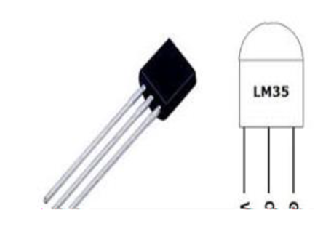

**3.2 Working model of all sensors**

* + 1. **PIR Sensor**

We can connect PIR output to any digital pin.

There is a jumper behind this module. If you move the jumper to L position, the sensor will ‘toggle’ (change state) whenever motion is detected. This is unlikely to be of much use in a practical applications. This mode is called non-triggering or Single Triggering mode.

Moving the jumper to the H position will result in the more usual sensor logic. The sensor will turn on when motion is detected and turn off a while after the last motion is detected. This sensor will reset the timer (which would otherwise turn the output off) each time motion is detected; this would be applicable, for example, for room occupancy lighting control where you don’t want the lights to blink off while the unit resets. This is called Retriggering mode. (or repeatable trigger mode).

There are also two potentiometers behind this module. By changing the SENSITIVITY potentiometer, you can reduce or increase the sensitivity of the sensor (clockwise increase), and also by changing TIME potentiometer the output delay after movement detection will be changed.

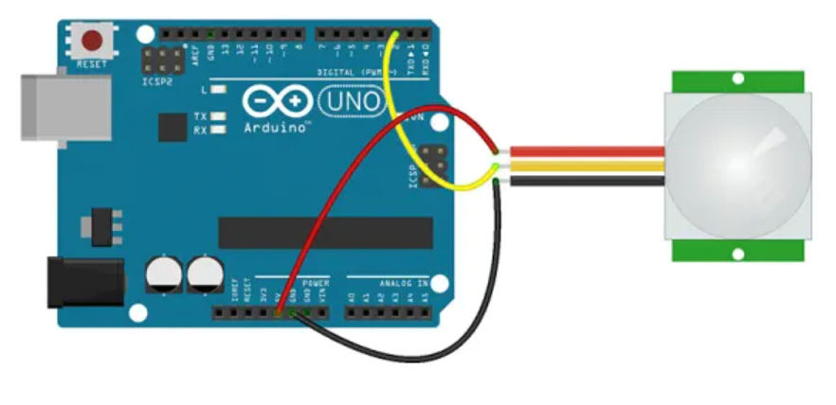

* + 1. **Temperature Sensor**

0.1V 🡪 -40 degree celcius

1.75V 🡪 125 degree celcius

T = (Vout – 0.5)*100 ---- for TMP36

T = (Vout) * 100 ---- for LM35

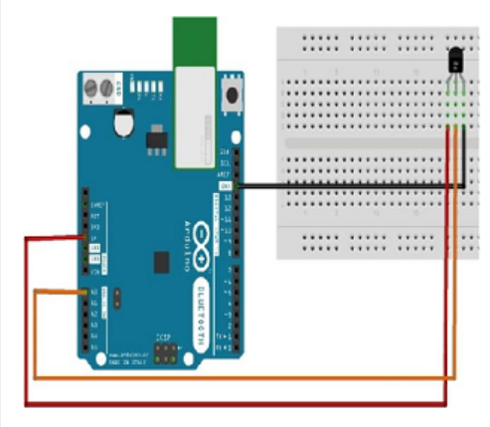

## PROPOSED ARCHITECTURE

Here we tend to be utilizing the temperature detector TMP36, temperature sensor which might be simply label to know the temperature of the surroundings (room) which is connected with Arduino. Arduino is related to the ThingSpeak cloud which provides instant and accurate visualizations analysis data denote by your devices to ThingSpeak, you'll be able to perform on- line analysis and process of the information in real time. This is usually used for prototyping and proof of idea IoT systems that need analytics. The IFTTT application program connects 2 or a lot of apps or devices together. It allows you to try {and do} one thing that those apps or devices couldn't do on their own,will be related to the cloud here that is used to send the warning (notification) to moveable device like mobile phone. The economical committal to writing is finished in the software system tool known as Tinker CAD and Arduino IDE are used.

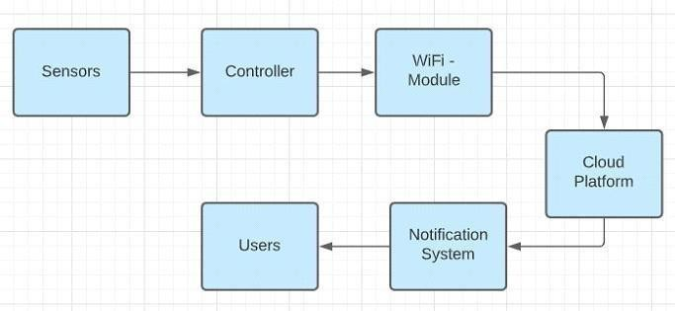

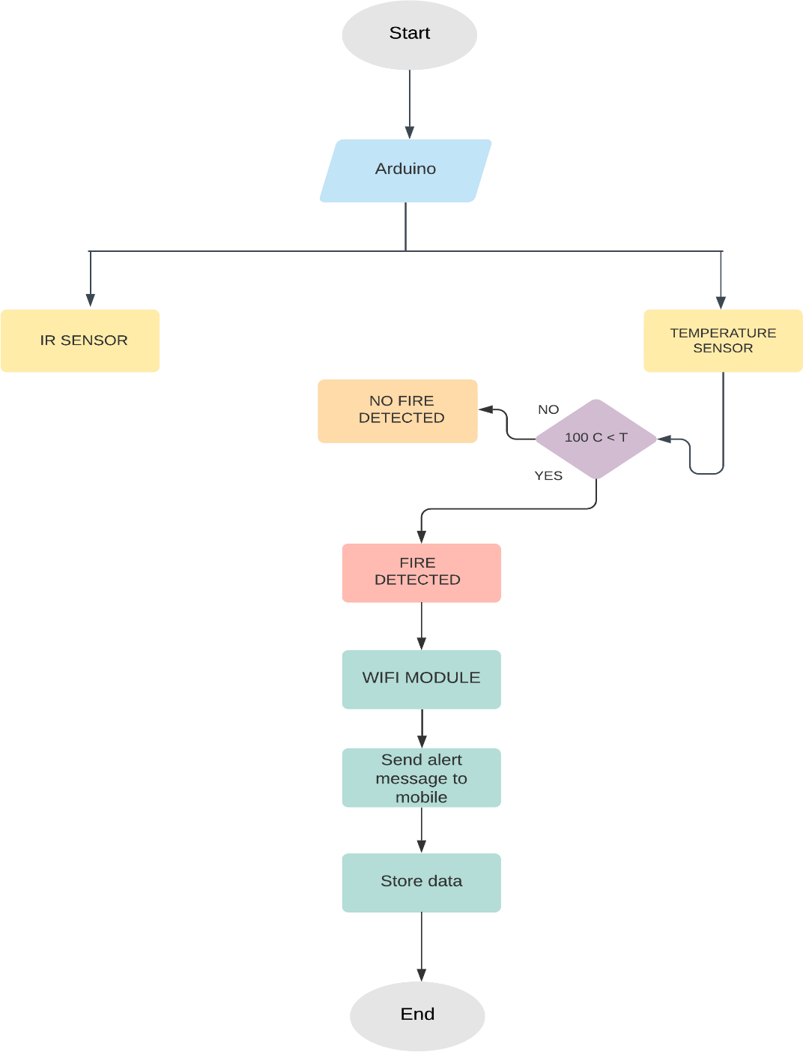**Flow Chart of the Architecture**

The proposed system has sensors which collects data from the physical world and is continuously sent to the cloud platform. When the temperature increases the preset threshold, the http webhook will be triggered and the notification is sent to the fire department. The amount of equipment to be taken by the fire departments can be moderated with the help of the displayed number of people in the affected area which has been added to the proposed system.

The IR detector is utilized here which is an device that measures and finds actinic ray in its close environment. In an exceeding outlined angle range, the detector components detect the warmth radiation (infrared radiation) that changes over time to the movement of people. There are two IR sensors related to the entry that are once more associated with the Arduino for a range of people within the regarded area which is shown in the alphanumeric display screen.

The information is understood and communicated in real time with things speak cloud and can receive an alert once temperatures exceed the given threshold price.

**CODE:**

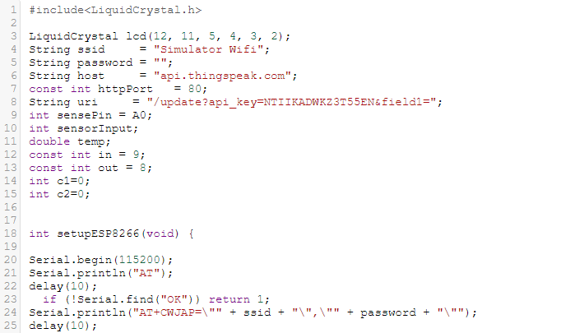

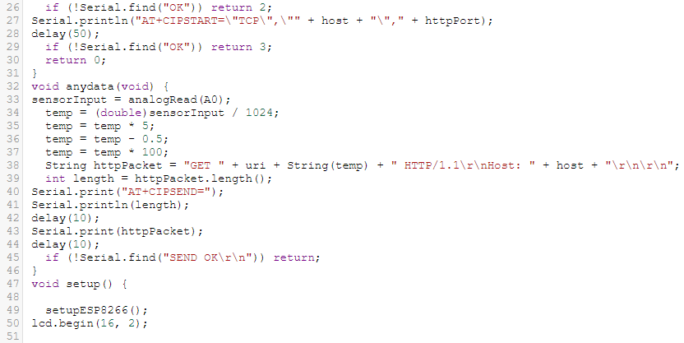

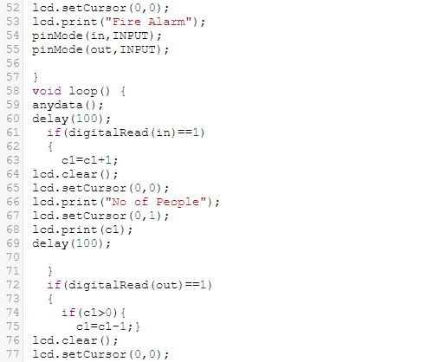

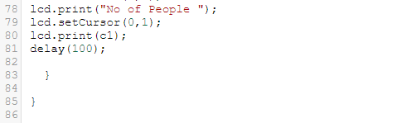

**5. HARDWARE /SIMULATION implementation**

**DESIGN:**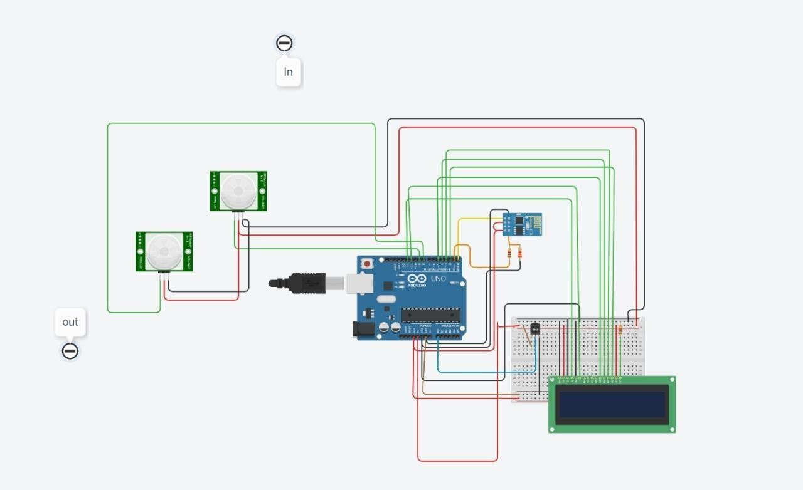

  **SIMULATION**

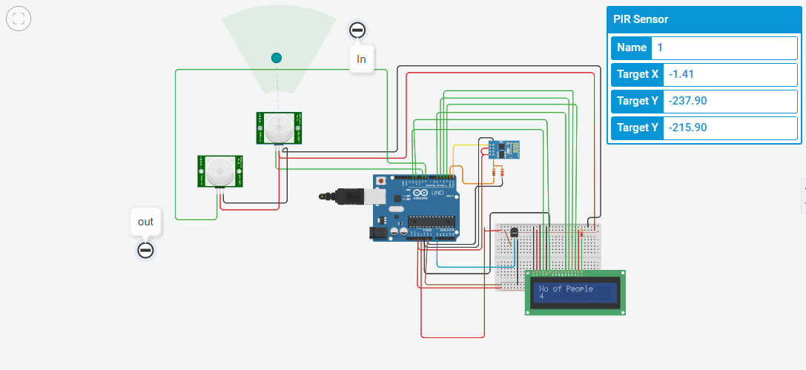

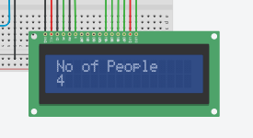

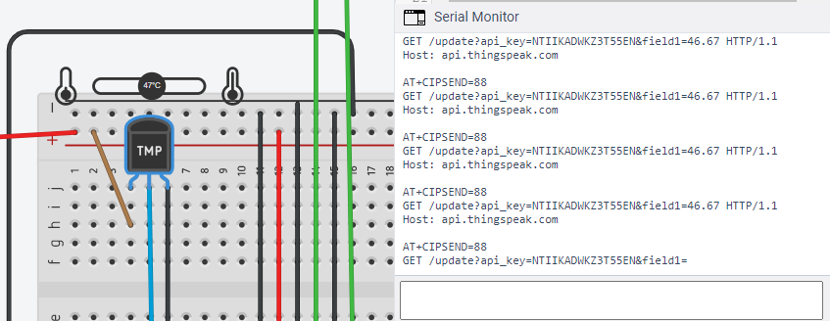

**We have to create a Channel in ThingSpeak from which we can visualize the data**

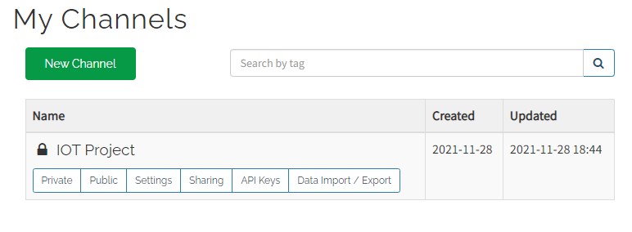

Fig . View of the channel where we can visualize the updated data in to cloud.

**Creating Description and Adding name to the field .**

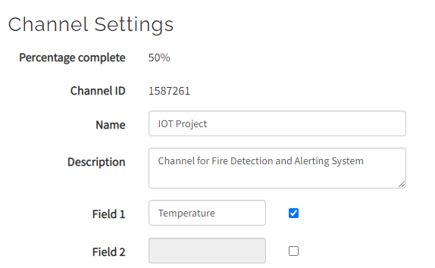

Fig . View of Channel ID and Fields Created in Channel

**An unique API key required to send the data to our cloud, which will be obtained.**

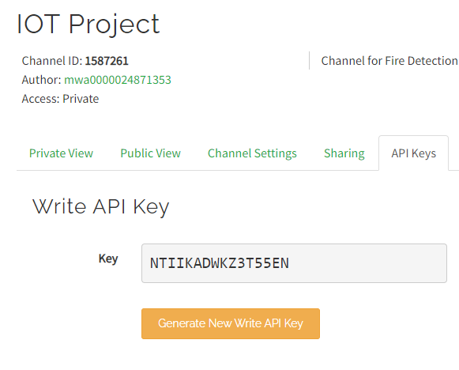

Fig .Write API Key of the Channel

**Thing HTTP which is used to connect the React and ThingSpeak channel.**

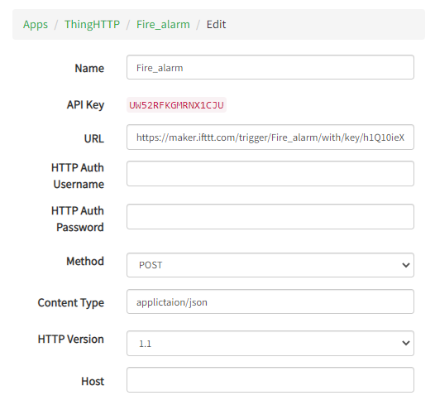

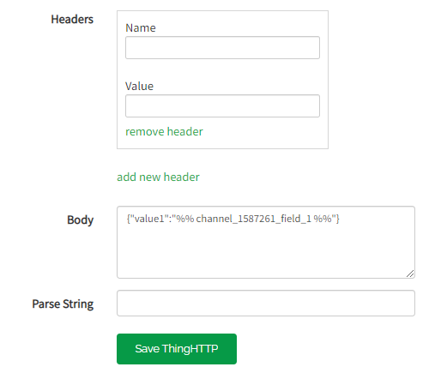

⦁ React is used to trigger the particular URL when the data in Thing speak cloud will crosses particular value (pre threshold).

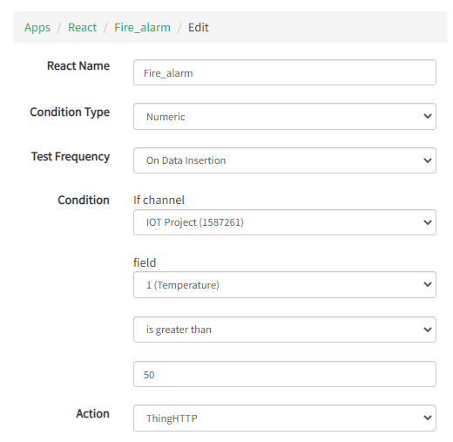

                          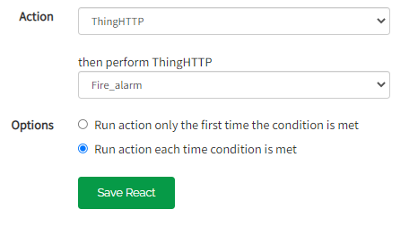

**IFTTT Configuration**

Here, we are using IFTTT Applet to alert the registered user when the webhook has been triggered.

**View of Applet**

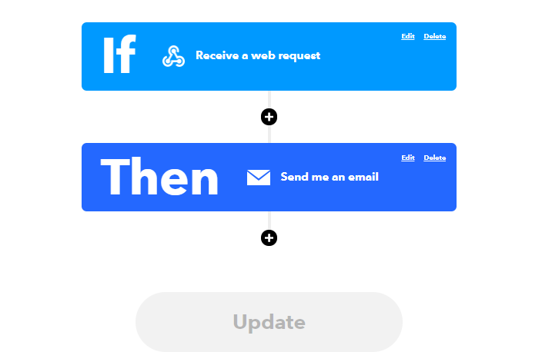

**Message that is sent from IFTTT Applet**

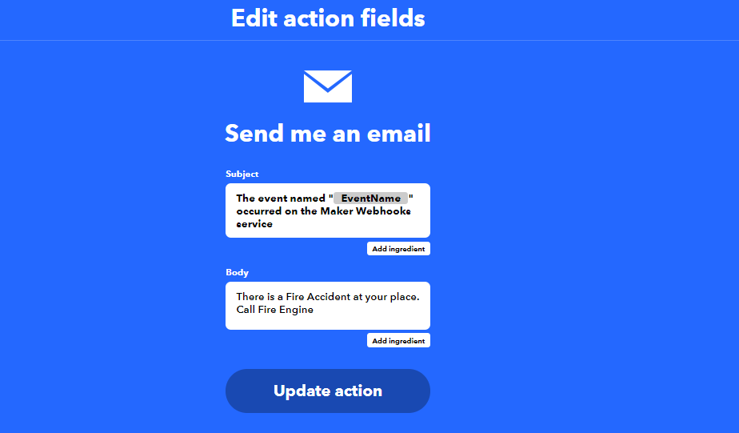

Mail will be sent to mail [nikhithaalokam@gmail.com](mailto:nikhithaalokam@gmail.com) when there is Fire

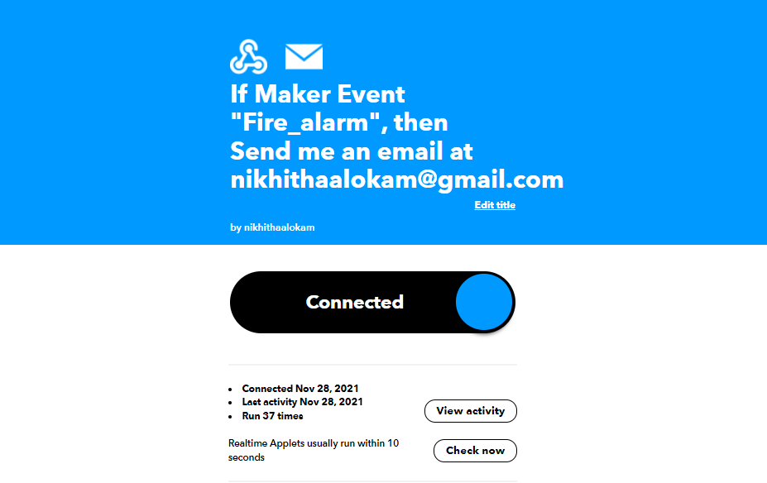

**Here we can get the url from the documentation.**

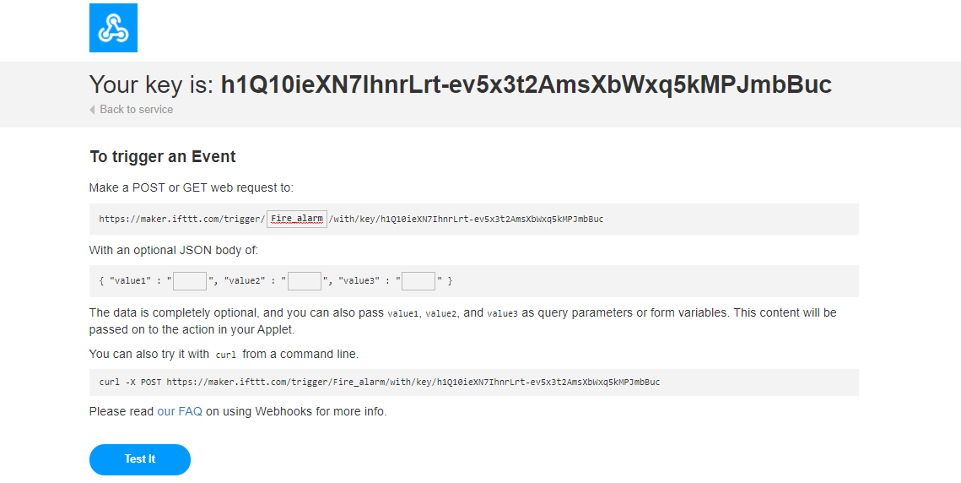

**6. RESULTS AND DISCUSSION**

**The Temperature is displayed in Serial motor**



⦁ Count is calculated with the difference in PIR sensors.

⦁ Indicating number of people through the LCD screens.





**Statistics of the data in Thing Speak Channel that is collected from Sensor using API Key**

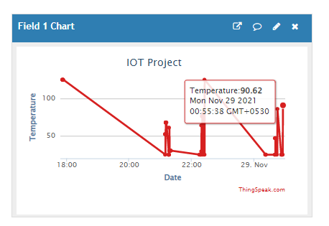

Fig . Temperature at 12:55 am is 90.62 c

**Alert mail when there is a Fire Detection**

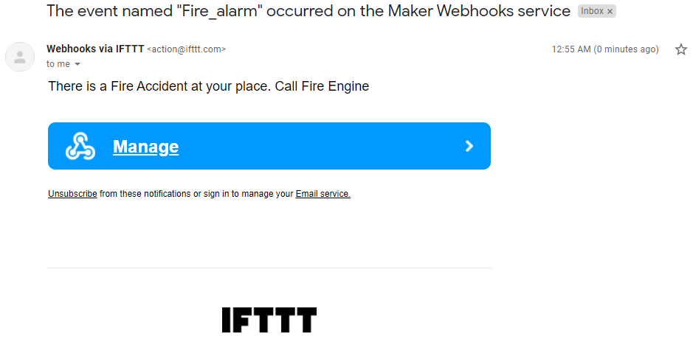

Fig. Alert mail after there is any Fire Accident

**7. CONCLUSION**

* Overall the project was successful.. The performance of the project met the original technical problem, which was to build a circuit that would sound an alarm when the heat in the atmosphere reach a hazardous temperature. Also the project was well under the overall project cost projected, making the project a good product since the application was successfully demonstrated and the circuit price was reasonable.
* The necessary part in fire police work is early and reliable detection and localization of the fire. The info collected through totally different detectors placed at different locations and information are sent to Arduino Uno placed in varied places. As a result the projected model is tested with ThingSpeak net interface and sensor data is recorded for testing of fireplace detection.

### 8. REFERENCE

1. J. Zhang, W. Li, Z. Yin, S. Liu and X. Guo, "Forest fire detection system based on wireless sensor network," 2009 4th IEEE Conference on Industrial Electronics and Applications, 2009, pp. 520-523, doi: 10.1109/ICIEA.2009.5138260.
2. K. L. Su, "Automatic Fire Detection System Using Adaptive Fusion Algorithm for Fire Fighting Robot," 2006 IEEE International Conference on Systems, Man and Cybernetics, 2006, pp. 966-971, doi: 10.1109/ICSMC.2006.384525.
3. G. Healey, D. Slater, T. Lin, B. Drda and A. D. Goedeke, "A system for real-time fire detection," Proceedings of IEEE Conference on Computer Vision and Pattern Recognition, 1993, pp. 605-606, doi: 10.1109/CVPR.1993.341064.
4. 2018 International Conference on Information Technology (ICIT)*,* Bhubaneswar, India, 2018, pp. 161-165, doi: 10.1109/ICIT.2018.00042.

<https://ieeexplore.ieee.org/document/8724380>

1. 2019 1st International Conference on Advances in Science, Engineering and Robotics Technology (ICASERT)*,* Dhaka, Bangladesh, 2019, pp. 15, doi: 10.1109/ICASERT.2019.8934458.

<https://ieeexplore.ieee.org/document/8934458>

1. [IECON 2016 - 42nd Annual](https://ieeexplore.ieee.org/xpl/conhome/7782522/proceeding) Conference of the IEEE Industrial Electronics Socie[ty](https://ieeexplore.ieee.org/xpl/conhome/7782522/proceeding) Florence, Italy.

DOI: [10.1109/IECON.2016.7794000.](https://doi.org/10.1109/IECON.2016.7794000)